**How to Install the Java Software Development Kit (JDK)**

The Java Software Development Kit (Java SDK or JDK) is an application created by Sun Microsystems to create and modify Java programs.

**Step 1)** Visit the <https://www.oracle.com/technetwork/java/javase/downloads/index.html>

website to find the **JDK environment** download. Scroll down until you find **Java SE Latest Version** and download **JDK**.  
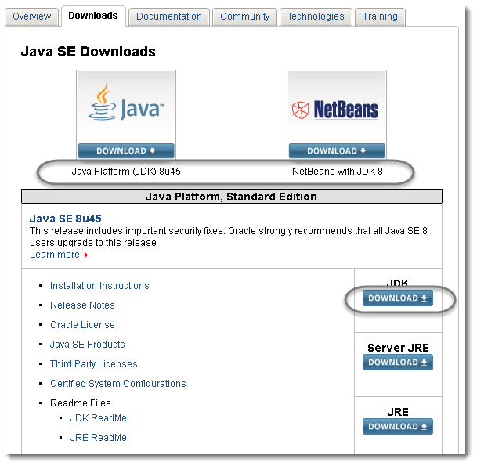

**Step 2)** Select the radio button to “**Accept License Agreement**” and choose the JDK that corresponds to your OS (Operation System -Windows, Mac, Linux, etc.)  
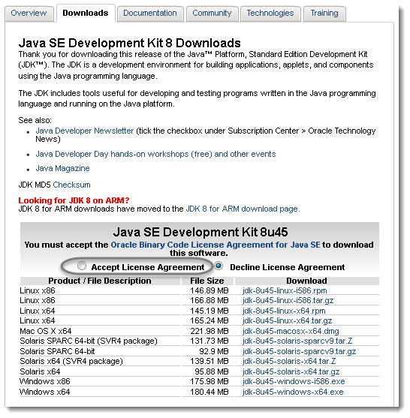

**Step 3)** The File Download dialog box appears prompting you to **Save** the download file.   
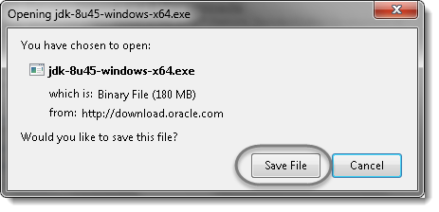

**Step 4)** Once the downloading is complete, **double click** the file to begin the installation of JDK.  
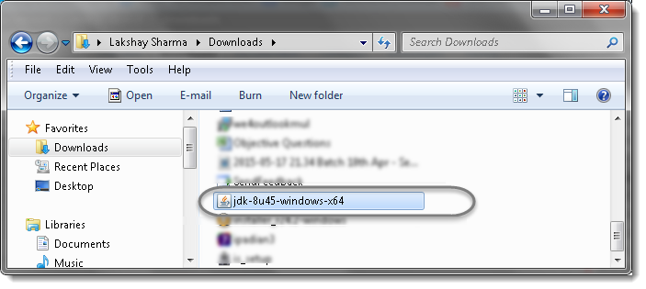

**Step 5)** To run the installer, click **Run**.  
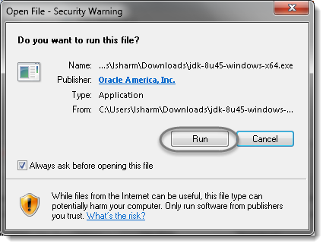

**Stepp 6)** The installation process starts. Click the **Next** button to continue the installation.  
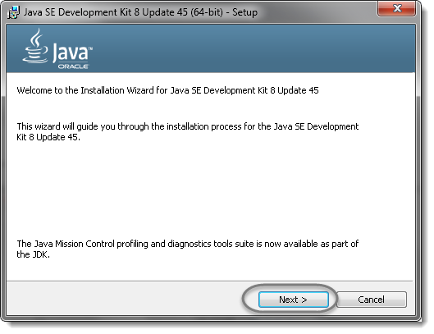

**Step 7)** On the next screen you will encounter some options. Just leave these alone and click **Next** unless you know what you are doing.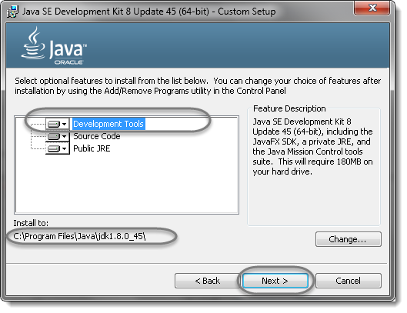

**Step 8)** After the initial installation is done, a pop up asking you where your source java files will be. You can choose to change where you want to keep your folder but it’s best to stick with what you were given first. Click **Next** to continue.  
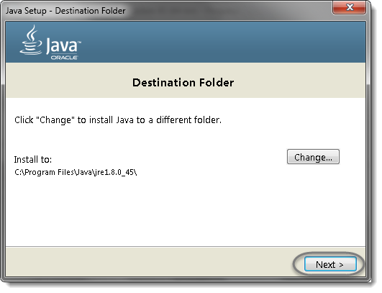

**Step 9)** Let the installation finish.  
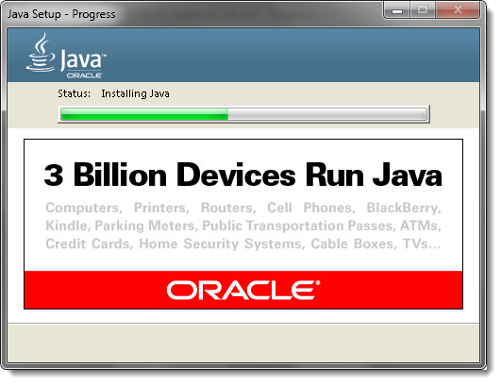

**Step 10)** A few brief dialogs confirm the last steps of the installation process; click **Close** on the last dialog. This will complete Java installation process.  
